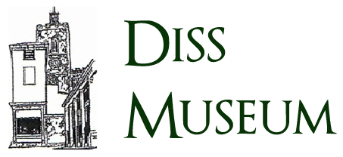

**THE R34 ADVENTURE – INTERACTIVE EXPERIENCE**

Diss Museum are in preparations to host the R34 adventure exhibition, to commemorate the centenary of the first double airborne crossing of the Atlantic Ocean. The exhibition will feature a variety of displays and performances showcasing the history of the R34 and its voyage.

To better engage attendees, we would like to offer an educational interactive experience involving the R34 and its historic mission.

**Audience**

The experience should be accessible to everyone, with a focus on appealing to school-aged children.

**Technical details**

There are no specific technical requirements for the development or distribution of the experience, though it is expected the final product be:

* thoroughly researched
* historically accurate
* contain interactive elements
* intuitive design
* be venue appropriate
* be fit for release prior to the exhibition dates

**What is required**

An individual or team eager to learn the history of the R34 and creatively pass the knowledge onto others. The individual(s) will be responsible for the design of the experience and all user interaction, as well as overseeing the public release.

The Museum has members who can aid with any research needs related to the history of the R34.